100% Report Submittal
Peach Springs Overpass

`
Flag-Tech Engineering Inc.
Jonathan Melendez
Breanna Smith
Yiyang Chen
Verneon Reed
Meshal Alotaiby
Yuliang Wang
Alex Goodman

Flag-Tech Engineering Inc.
Civil Site Design █ Structural Analysis █ Construction Planning
240 W. Saunders Dr. #172
Flagstaff, AZ 86001

Jonathan Melendez, Flag-Tech Engineering Inc. Leader
JonMelendez92@gmail.com
Phone: (661)-733-9984

Dear Mrs. Alpert,

Flag-Tech Engineering is proud to present the following conceptual design for one of the alternatives for a new crossing in Peach Springs, Arizona. The following document contains the following information:

Project Description

Background

Technical Sections

Cost of Implementing the Design (Estimated at 3.7 Million Dollars)

Please review this document and contact us with comments and questions that may arise.
Thank you for your time and attention,
Flag-Tech Engineering Inc.
Jonathan Melendez Breanna Smith Verneon Reed
Yuliang Wang Yiyang Chen Alex Smith Meshal Alotaiby

Table of Contents

1. Acknowledgements 3
2. Project Description 3
3. Background 4
4. Technical Sections 4
4.1 Testing/Analysis 4
4.2 Identification of Alternatives 4-5
4.3 Identification of Selected Design 5-6
4.4 Soils/Geotechnical Report 6-7
4.5 Hydrology & Hydraulic Plan 8
4.6 Hydrology Analysis 8
4.7 Erosion/Sediment Control 9
4.8 Hydraulic Structure Plan 9-10
4.9 Structure 10
4.10 Geometry 10-11
4.11 Traffic Control Plan 12
4.12 Environmental Analysis 12
5. Cost of Implementing the Design 12-15
4.1 Cost of Staffing 12-13
4.2 Cost of Engineering Services 14
4.3 Cost of Materials and Labor 14-15
6. References 16
7. Appendix 17-28
6.1 Peach Springs Aerial Map of Site 13
6.2 Existing Road and Proposed Road Alignment 14
6.3 Entire Existing Available Road 15
  - Proposed Road Alignment 16
6.5 Truxton Wash and Railroad Section Cut 17
6.6 Bridge Design and Geometry 18
6.6 FHWA Codes 19
6.6 ADOT Codes 20-28

1. Acknowledgements

Flag-Tech Engineering Inc. would like to offer our special thanks to Dr. Charles Schlinger and Ian Braun for their valuable time and use of Lidar equipment during our recent survey at our project site in Peach Springs, Arizona. Assistance with the Lidar survey data by Ian Braun was particularly helpful by his extended work in creating a surface for the team in AutoCAD and providing us with a detailed map of all data points needed to perform analysis on the project. Additional thanks to Associate Chair John Tingerthal, the team’s Technical Advisor on the capstone project, for his time, guidance and feedback on the project. The team would also like to extend a thanks to Dr. Odem for his supervision on the project and in helping the team with management of time and resources for the project. The team would additionally like to express our gratitude to Dr. Bero and Kim Coyle-Pohs in assisting the team with all paperwork and courses necessary for the site evaluation in Peach Springs to perform the Lidar survey. Additionally, the team would like to thank our clients Julie Alpert, Transportation Planner Hualapai Tribe of the Public Services Department, and Kevin Davidson, Hualapai Tribe Planning & Economic Development Director, in providing the team with contact information and documents, in which were pertinent for the development of our project. The team would like to extend a special thanks to Sayeed Hani, Utility Engineering Coordinator, with Arizona Department of Transportation, ADOT, for his involvement in assisting the team with data pertaining to the Burlington Northern Santa Fe Corporation, BNSF. Finally, the team would like to extend a thanks to Chris Howell, Director of Tribal Relations for BNSF, for his direction and information pertaining to our Lidar survey field evaluation. Without each and every individual’s guidance and support on the project, Flag-Tech Engineering Inc. would not have been able to design the grade separation, thank you.

2. Project Description

The objective of this project is to analyze and enhance the transportation conditions of the existing at-grade crossing at Diamond Creek Road and Burlington Northern Santa Fe (BNSF) Railroad in Peach Springs, Arizona. The project location is within the Mohave County and the Hualapai Indian Reservation. The current crossing includes flashing lights and automatic gates, however, advance warning signs are missing from the northbound approach. Trains pass approximately every 15-20 minutes, with frequent stops at the crossing for extended periods of time, blocking the only access to residential and commercial areas. This also restricts travelers and emergency vehicles from crossing the railroad. In addition, the railroad also causes significant noise pollution to the community and visitors. To improve the conditions at the crossing, four alternative railroad crossings were evaluated from the Arizona Department of Transportation (ADOT) Long Range Transportation Plan (LRTP) study for the Hualapai Indian Tribe. From the proposed alternatives, the recommended crossing design will produce a more efficient infrastructure for the local community as well as the traveling public. Project evaluation includes existing conditions relative to vehicle traffic, rail traffic, pedestrian traffic, affected environment and environmental concerns. To develop the preliminary design, the following policies, requirements and standards were to comply with, but are not limited to, Burlington Northern Santa Fe (BNSF) Railway, Arizona Department of Transportation (ADOT), Federal Highway Administration (FHWA), American Railway Engineering and Maintenance (AREMA), and the American Association of State Highway and Transportation Officials (AASHTO).

3. Background

The Burlington Northern and Santa Fe Railway (BNSF) runs through Peach Springs, Arizona, which is located 113 miles west from Flagstaff and 50 miles east from Kingman. Peach Springs is a small town of approximately 1,100 people from the Hualapai Indian Reservation and it is within Mohave County. The elevation for the site is approximately 4,800 feet. The project site is located at the intersection of the BNSF railroad tracks and Diamond Creek Road. The existing structure of the railway is an at-grade railroad crossing, which has many of the associated problems mentioned in the Project Description. The decision has been made by Flag Tech Engineering Inc. to convert the at-grade intersection to an overpass. (Please refer to Figure 6.1 in Appendix 6 to see a satellite photo of the project site and surrounding area) [1].

4. Technical Sections

  - Lidar Survey
A light detection and ranging survey was completed at the project site in Peach Springs, AZ. The team surveyed approximately 870 feet of the available road length for the design of the overpass. The survey consisted of a light detection and ranging (Lidar) unit which uses remote sensing technology to measure ranges by use of a pulsed laser light to sense objects. The Lidar equipment that was used was a RIEGLVZ-400 with a NIKON D3300 camera attached to capture images from the scan. The RIEGL VZ-400 unit rotated 360 degrees capturing all points with in a 100 foot diameter. The unit quickly rotated taking fully linear, unidirectional and parallel scan lines. The unit then reported the points to the data collector, which was then uploaded onto the computer and a full surface was created using AutoCAD [2]. (Please refer to Figure 6.2-6.5 in Appendix 6 to see a detailed surface in AutoCAD of the project site).

  - Identification of Alternatives
The Arizona Department of Transportation (ADOT) provided the team with the Long Range Transportation Plan (LRTP) for the Hualapai Reservation, where four design alternatives were drawn up [3]. ADOT’s LRTP provides cities with expanded travel choices, in which technical information and public input assisted them to develop new and improved road designs. The LRTP is set up to help cities make positive investments in transportation, which allows the residents and visitors to move freely on their roads. The LRTP also provides feedback on existing roads for the safety of travelers. In Peach Springs, AZ, travelers face numerous obstacles as they move through a current at-grade crossing with the railroad. In order to provide a safer route through the town the LRTP has provided the tribe with four preliminary design alternatives to eliminate the current at-grade crossings. Preliminary design alternatives are shown in Figure 4.2.1 on Page 5, where option one was the existing road redesign of Diamond Creek Road and a 500 foot overpass would have to be constructed. Design alternative two was an extended road from Rodeo Way to State Route 66 and includes construction of a new 450 foot road overpass. Design alternative three was a road realignment to Rodeo Circle Road and would connect to Nelson Road with a new 250 foot road overpass. Design alternative four consisted of an underpass just west of the existing at-grade crossing at Diamond Creek Road. Considerations for each design alternative were taken into planning in the LRTP, where each alternate design was assessed for connectivity, access and functionality. Design one, the existing road, obstacles consisted of obstructing the only crossing in the area and limit connectivity during the construction of the grade separation. Design options two and three will increase traffic at Nelson Road in which the road would need to be upgraded to accommodate the increase in traffic flow. Design option number four would need extensive storm water management and a pump station to remove excessive storm water [3].
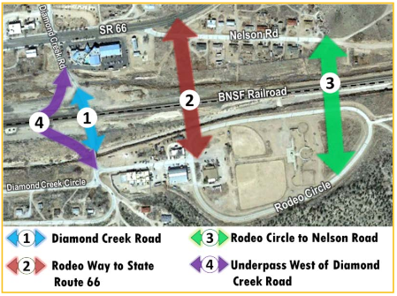
Figure 4.2.1- Map of Four Design Alternatives [3].
  - Identification of Selected Designs
The team completed a decision matrix based off of each design and five grading criteria which include safety, functionality, geometry, cost and client/stakeholder preference. Each of the four designs were carefully assessed in each category and can be seen in Table 4.3.1 on Page 5. The team decided to give each section a weight based on the input from the clients, Julie Alpert, Kevin Davidson and Philip Wisely and the stakeholders, The Hualapai Indian Tribe, BNSF Railway, ADOT, FHA, and the County of Mohave. The client expressed that safety was a main concern, which resulted to be a maximum weight of 5. The functionality of the road received a maximum weighting of 4 due to the need for working option. The geometry of the road also received a maximum weight of 4 due to the available road length of all four design options. The cost attained a maximum weight of 4 also, due to the small differences in total cost for the overall designs. Finally, the team gave the client/stakeholder criteria a weight of 5 to reflect the importance of their request.

The first to be assessed was design alternative one, the existing at-grade crossing at Diamond Creek Road. The team assessed the road to be highly safe at a weight of 4, due to the proximity to the businesses and recreational resources around the town. Functionality of Diamond Creek overpass also scored high due to the current function of the road, which is directly off Route 66 and ties straight into the main road south of the tracks. For the geometry of design one, the road had the second to most available road length however, it does curve on the north side, which was taken into consideration and given a score of 4. The client and one of our main stakeholders, BNSF expressed a high desire for the team to choose option one and as a result of that the team scored design option one at a 5. Design alternative number one received an overall score of 97 which include the weighted average. Design option number two was not chosen due to a lack of desire from the client and the overall safety of the home owners on Rodeo Way. Since the main road would have to tie into a residential district the team felt safety would be proposed as an issue. Design option number two received an overall score of 69 and was not chosen. Design option number three was not chosen due to safety issues and functionality. However, similarly to design option two the main road would have to tie into a residential district and the client expressed his/her safety concerns. Design option number three scored a 77 in which option number one controlled. Finally, design option number four was not chosen due to the excessive cost associated with building an underpass and the closeness in proximity to the Truxton Wash. The stakeholders through BNSF conveyed to the team their disapproval to an underpass due to the structural components of their tracks. Design option number four created a problem due to the geometry of the road. Where large semis and trucks would not be able to make the 180 degree curve required to design the road. Design option number four received the lowest score with a total of 45 overall points. Overall, design option one, the existing Diamond Creek Road, was chosen over the other three design alternatives. Design option one was chosen because it scored highest in every category compared to the other alternatives.
Table 4.3.1- Decision Matrix for Four Preliminary Design Alternatives.

  - Soils/Geotechnical Report
Using the provided Engineering and Testing Consultants, Inc. geotechnical report conducted for the Hualapai Cultural Center in 2007, the soils and geotechnical investigation was used to determine soils suitability to support the grade separation infrastructure, pavement structure, site grading, and drainage [4]. Due to time constraints and lack a report in the project site, it was assumed that the soil around the Hualapai Cultural center would be similar if not the same, the area of testing provided in the red square in Figure 4.4.1. Soil Classification is based on Unified Soil Classification System and ASTM Designations D-2487 and D-2488. Coarse Grained Soils have more than 50% of their dry unit weight on #200 sieve, described as boulders, cobbles, gravel or sand. Fine grained soils have less than 50% of their dry unit weight retained on #200 sieve, described as clays if they are plastic and silts if they are slightly plastic or non-plastic. ETC performed five exploratory test borings to determine general subsurface soil conditions. The subsurface soils consist of low plasticity, clayey sand with varying amounts of gravel. Loose granular soils were found at depths of 2.5 feet to 7.5 feet. The loose granular soils will provide reduced support for infrastructures, thus, to minimize potential settlement, ETC recommends over-excavation and compaction of the soils below foundation infrastructures. Loose soils were found with thickness of 2.5 to 4 feet. ETC recommends that the bottom of footing trenches be over-excavated and replaced in moisture conditioned and compact lifts. ETC recommends that foundations be placed on adequately compacted soils, at a minimum depth of 18 inches below lowest, adjacent, finished grade, and a maximum allowable footing pressure of 1,500 psf. Due to low plasticity granular soils on the site, a portion of anticipated settlements are expected to occur during construction. ETC recommends a Site Class “C” be used for seismic considerations, per Table 1615.1.1 of the 2003 International Building Code. Soils should be compacted to meet the criteria listed in Table 4.4.1.
Table 4.4.1. Soil Compaction Criteria.

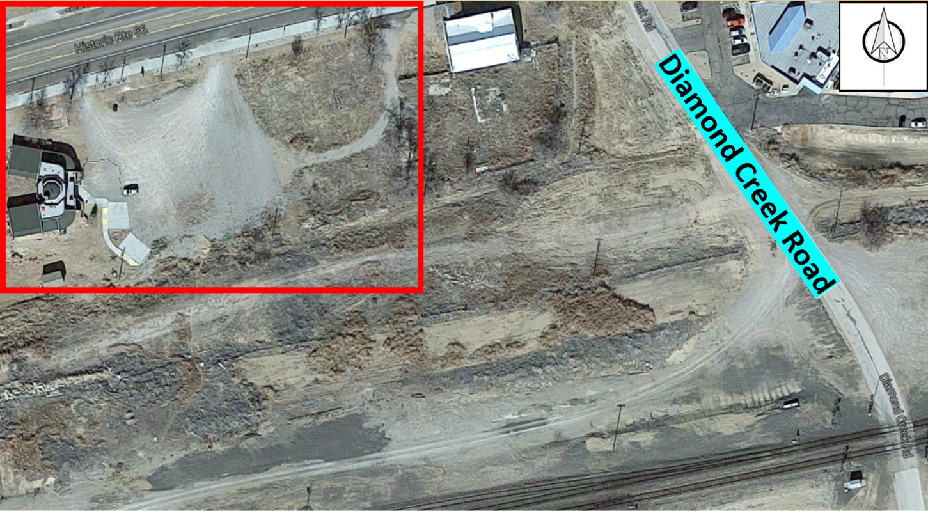
Figure 4.4.1. Boring Location Map for Hualapai Cultural Center.

Hydrology & Hydraulic Plan
A preliminary environmental evaluation of the project location was conducted in which the existing environmental databases were analyzed to identify potential environmental issues.

Hydrology Analysis
The existing watershed for the Peach Springs Basin was obtained from USGS. Truxton Wash, located in Peach Springs, is the only intermittent stream within the basin. Figure 4.6.1 shows watershed including several major tributaries, of Truxton Wash. A drainage analysis has been conducted to determine the impacts on the project location’s hydrological features. An impact to hydrological features from the recommended final design is considered to mitigate potential flood event water surface elevations.
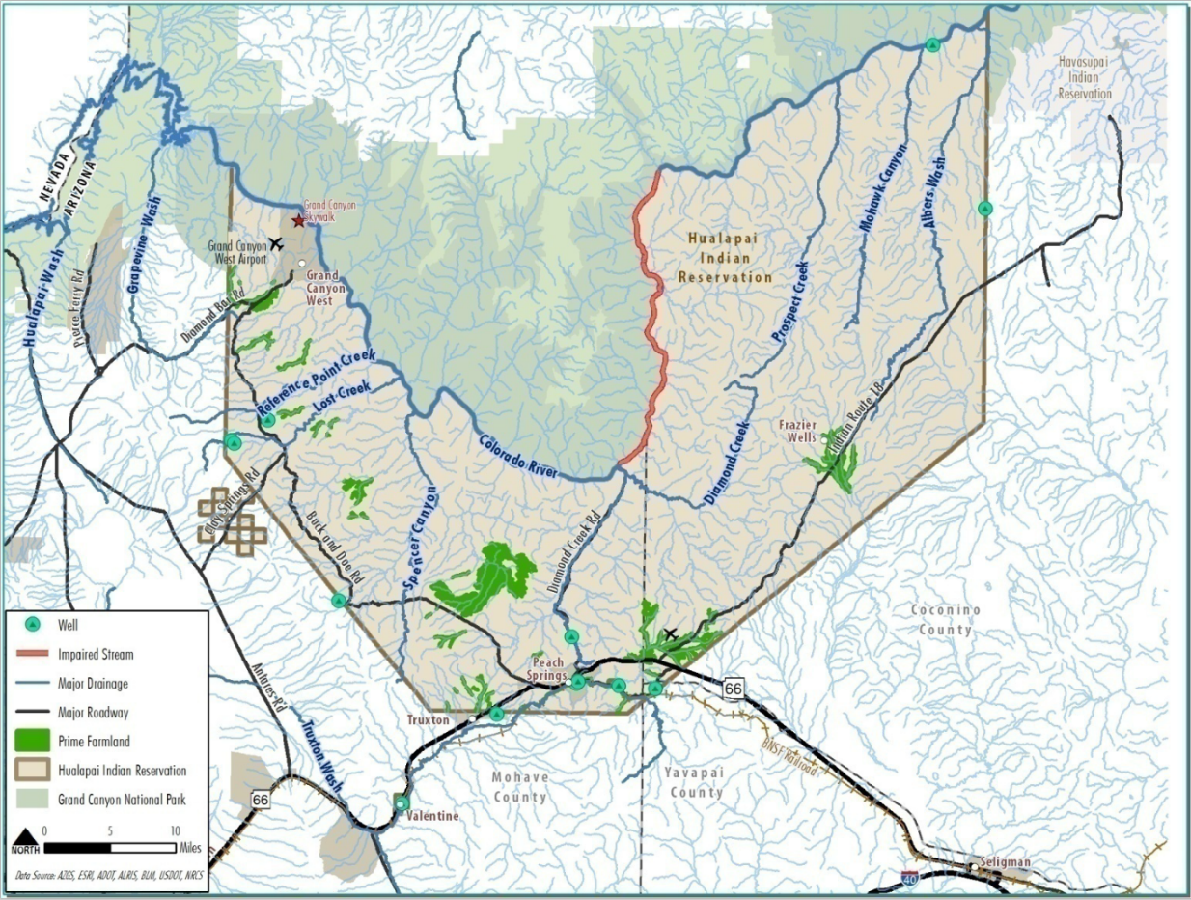

Figure 4.6.1- Hydrological Features for the Hualapai Indian Reservation.
Peak streamflow data was obtained from USGS, data number 09404343, as shown in Table 4.6.1. The drainage area for the Truxton Wash was reported at 380.3 square miles. The recorded and most recent peak stream flow is recorded at 7,430 cfs and 967 cfs, respectively.
Table 4.6.1- USGS Peak Streamflow Data for Truxton Wash.

Erosion/Sediment Control
The erosion control measures consist of disturbing the work area as little as possible with a low time period of disturbance, preserving vegetation, minimizing runoff volume flow onto the site, reducing volume and velocity of storm runoff from the site, and installing temporary or permanent soil stabilization measured. Best Management Practice also help minimize site disturbances.
The sediment control measures consist of installing temporary structural barriers such as silt fences, using check dams and other structures to decrease channel flow velocities, provide sediment filters or traps at storm drain inlets, remove sediment by treating flows from dewatering activities, route runoff through sediment traps or sedimentation basins, and provide final stabilization of disturbed areas through revegetation. Sediment control BMPs treat runoff for particulates after they have been eroded and washed offsite.
Since the side slopes for the engineered soil are at a maximum value of 1:1 erosion control is needed in order to bind the soil tightly and cover it with dense foliage. It is recommended to plant groundcover plants on the engineered fill side slopes of the bridge to prevent sediment build up in the Truxton wash as well as preventing surface erosion around the supports. Additionally, hydroseeding is recommended in order to provide soil holding capacity until the ground cover matures.

Hydraulic Structure Plan
Using the Lidar survey data, a surface was created in Autodesk AutoCAD Civil 3D software as seen in Figure 4.8.1. Because the survey data was obtained on surfaces about the Truxton Wash Bridge, the cross sectional view was generated 10 feet downstream from the culvert, as shown in Figure 4.8.2.

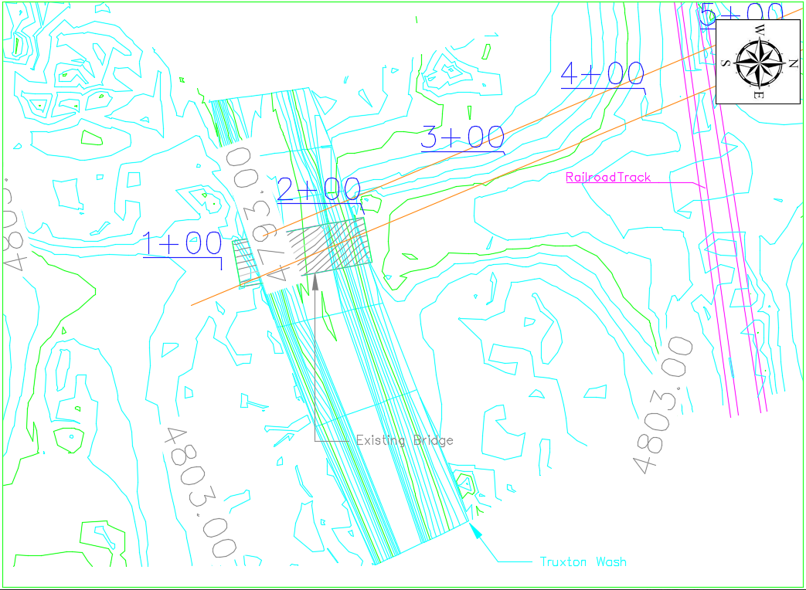

Figure 4.8.1- Contour map of the Truxton Wash, south of the railroad crossing.
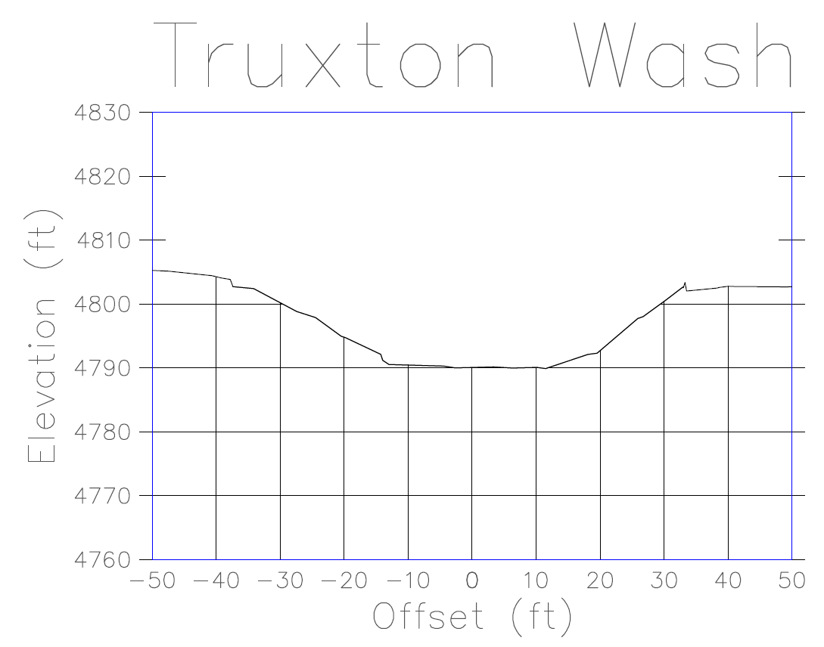

Figure 4.8.2. Cross Sectional view of the Truxton Wash.

Structure
The structural portion of the overpass consists of four major parts. These include the following: geometry, materials, loads and pedestrian path. All of the structures constraints were determined based off of BNSF requirements as well as various other codes including The Federal Highway Administration and The Arizona Department of Transportation. Additionally, precast concrete slabs and beams were selected due to BNSF constraints [5] [6] [7]. Please see Appendix 6.7-6. The structure required a design for the superstructure, this involved a simple design of the layers which included concrete girders and precast concrete. A detail of the dimensions for this superstructure is shown in figure 4.9.2. Precast concrete abutments and retaining walls were designed for the overpass because the decision to use class 4 and class 2 engineering fill on the north and south side would be cheaper and simpler than other alternatives. Below is figure 4.9.1 that shows the fill and the dimensions of it within the retaining wall.
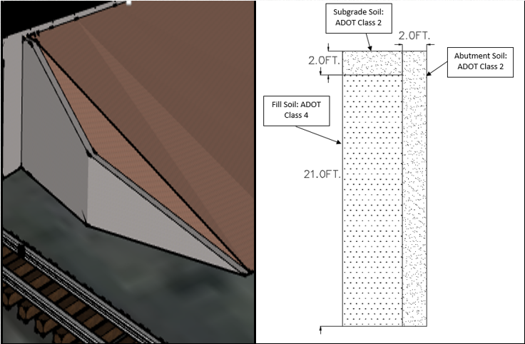
Figure 4.9.1 – Detail of Engineering Fill and Dimensions
Utilizing the AASHTO and BNSF requirements the superstructure had to be designed to meet the minimum requirement of 5.5 feet.
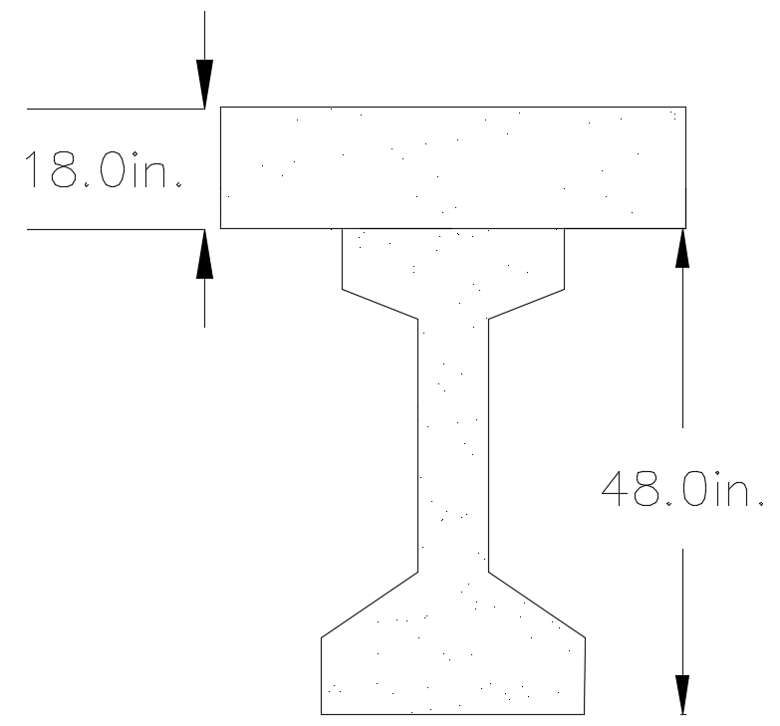
Figure 4.9.2 – Dimensions of Superstructure
For the structure, the abutment and retaining wall were both comprised for class S concrete which is a concrete that contains varies different level of sulfate depending on the strength required, by AASHTO it is one of the more common materials used for construction. The dimensions of the abutment were noted as 10 feet by 23.5 feet (ADOT [BGD 9.7.1.1]) and the retaining wall was noted to have dimensions 100 feet by 2.5 feet by 23 feet. Below is the figure that shows these two structures isolated in the project site.
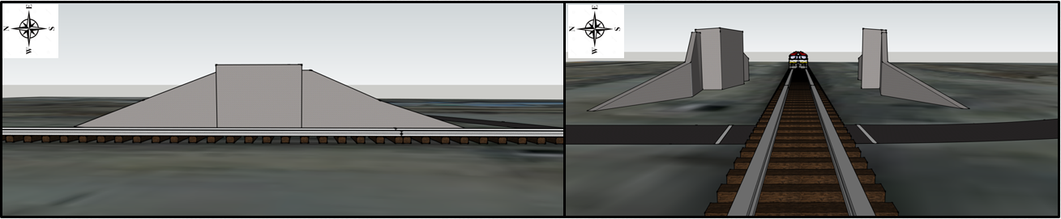
Figure 4.9.3 – Abutments and Retaining Walls Isolated
Finally to top off the soil that will be laid out will be a foot and a half of Portland cement concrete. The final result is shown below in figure 4.9.4.
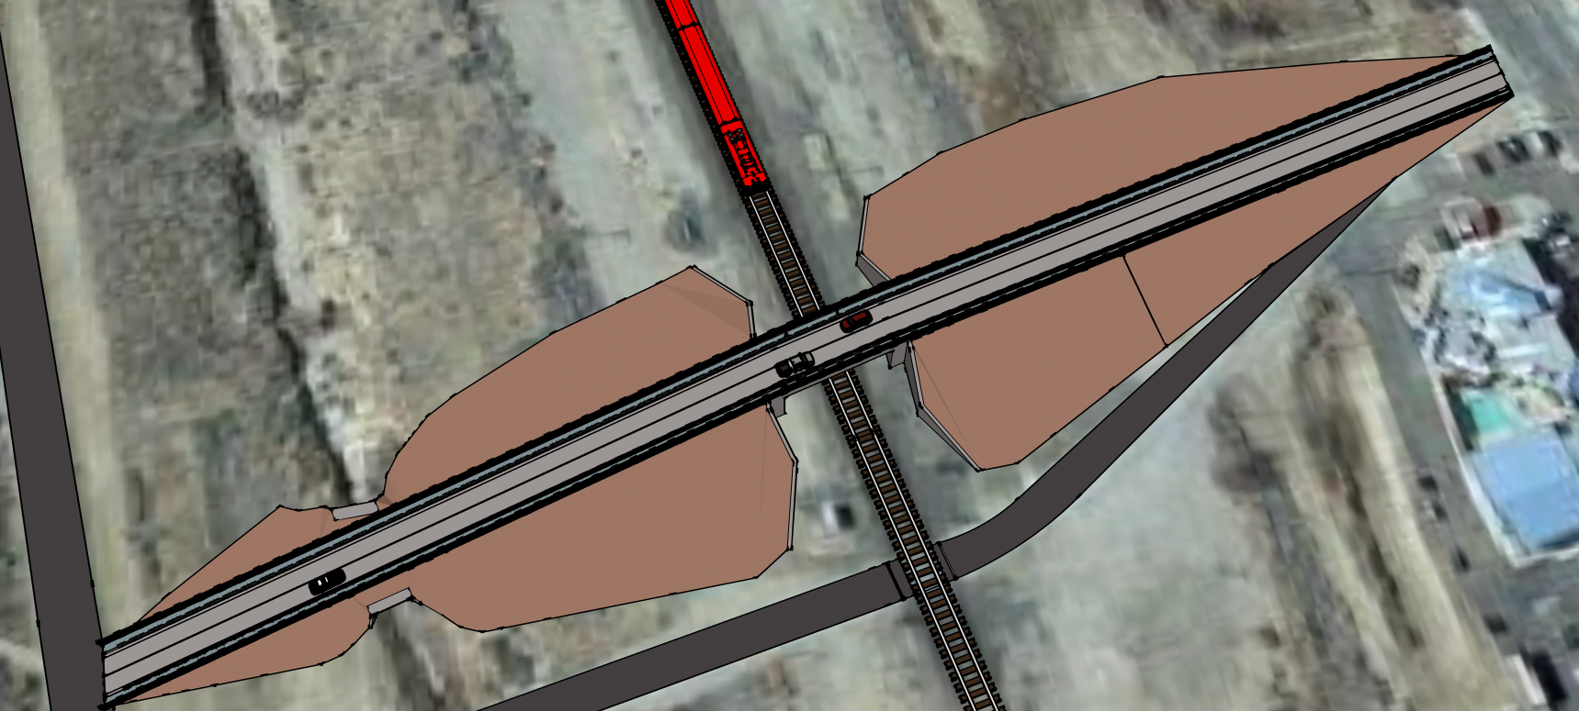
Figure 4.9.4 – SketchUp of Overpass

  - Geometry
Utilizing the constraints that were researched, Flag-Tech Engineering Inc. was able to create a sample drawing for the dimensions of the structure, this is not the final design but a basis that will be refined in the upcoming weeks. Utilizing the surface obtained from the LIDAR survey, multiple distances were determined which are shown in Table 4.10.1. A road re-alignment will be constructed due to the curvature of the road at the bridge decking and can be seen in Appendix 6 Figure’s 6.2 and 6.4 [8].

Table 4.10.1 Various Distance on project site
Section | Distance found from surface (ft.) | Distance used in design (ft.)
A-B | 229.98 | 230
B-C | 294.88 | 295
C-D | 33.59 | 34
D-E | 214.01 | 214
E-F | 87.21 | 87
F-G | 111.39 | 111

Please see Below Figure 4.10.1 for a detailed map of each location of section in Table 4.10.1.
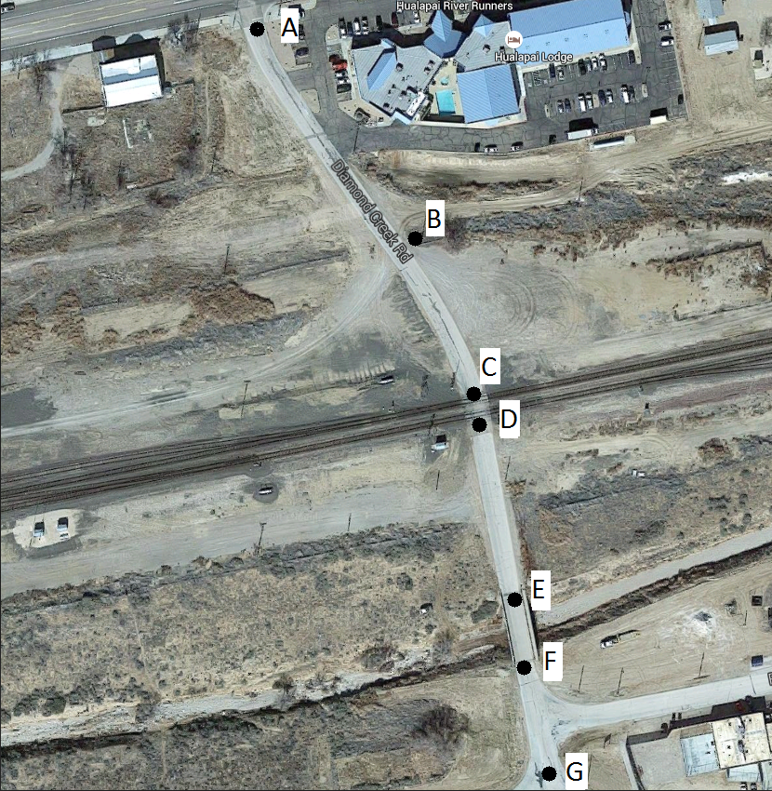

Figure 4.10.1- Detailed Map of Sections Mentioned in Table 4.10.1.
Additionally, in the appendix section within the contents of the AutoCAD drawings, Figure 6.6 Sheet E, there is a sketch showing the dimensions of the bridge based off constraints and requirements of the region and codes. As required by BNSF there was a ten foot high fence that was added to the overpass to ensure the safety of railroad workers. The overpass based off of ADOT codes has a vertical clearance of 23.5 feet and a horizontal clearance of 18 feet on each side of the tracks [9].
  - Traffic Analysis
The number of cars passing through Diamond Creek Road and the BNSF Crossing is 106 cars which corresponds to 36.9% of the population. For the pedestrian crossing count, it was determined that 38 people walked across the tracks daily which is 13.2% of the population. The maximum daily trains crossing through the city is 86. For the level of service, the following variables were determined for the calculation of level of service: (FFS ) = 47, Width Lane = 11 ft, Shoulder Lane = 2 ft, Peak Hour Factor ( PHF ) = 0.9, Demand Volume = 4.42 Veh/hr, Access point/mile = 40, Terrain ( Level ). The level of service equation contains the following variables:
    - ${ATS}_{d}$ = Average Traffic Speed
    - FFS= Free Flow Speed
    - PHF= Peak Hour Factor
    - PFFS= Percent Free Flow Speed
    - $V_{d}$= Analysis flow rate in analysis direction
    - $V_{0}$= Analysis flow rate in opposing direction
Then, we can calculate the LOS as the following:
- ${ATS}_{d}=FFS -0.00776\left(V_{d}+V_{0}\right)-F_{np}$
- ${ATS}_{d}$ = 47 – 0.00776 (106+106) - 1.8 = 43.55488 mph
- PFFS = $\frac{{ATS}_{d}}{FFS}$ = (43.55488/47) = 0.926 = 92.6%
- Since PFFS = 92.6% , LOS = A
The result of this level of service concludes that the roads can be designed to have one lane.
  - Environmental Analysis
A detailed biological analysis to determine the specific presence/absence of projected species and potential mitigation measures. For the design phase, coordination will need to occur with the AZGFD, the USFWS, and the Arizona Wildlife Linkages Workgroup to incorporate elements to protect wildlife from roadway traffic and to allow for the safe wildlife movement across the study area. For the construction phase, communication recommended between the Hualapai Indian Tribe, BLM, AGFD, USFWS, Mohave County, Coconino County, and Yavapai County to coordinate measures to protect all environmentally sensitive species in the area during the construction phase [10] [11].

5 Cost of Implementing the Design

The cost of the entire project design contains three parts: the cost of staffing, the cost of engineering service and the cost of materials.

5.1 Cost of Staffing

For the cost of staffing, the team evaluate the cost for the eight main tasks which include site evaluation, standards and requirements, design alternatives, final design, intersection/ crossing, hydraulic, environmental analysis and project management, also the project meetings. The cost of staffing was done for all four of our personnel, the Senior Engineer, Engineer, Engineer in Training, E.I.T and Intern. For each of our tasks the hours were divided for each personnel title. The first task site evaluation included two trips to Peach Springs, AZ, in order to analyze the site area, communicate with the clients and set the site for the Lidar survey at Peach Springs. The second task included reviewing standards and requirements from ADOT, ASSHTO, BNSF and were used in the final design. The third task included the design alternatives, where four alternative designs including three overpass and one underpass, were evaluated for safety, functionality, geometry, cost and client/stakeholder preference. Tasks five through seven were design related tasks such as; traffic analysis, hydraulic analysis and environmental analysis, where the team ran software such as HEC-RAS and performed hand calculations. Based on all the information, the team determined the design criteria and the dimensions of the final design, which is shown in design details in Civil 3D as well as a concept design model using Google SketchUp. The total hours for each personnel and cost for each task can be seen in Table 5.1.1.

Table 5.1.1: Staffing Cost per personnel.

The total hours for each tasks, and the personnel hours for each employee can be seen in Table 5.1.2 and Table 5.1.3, respectively. The Senior Engineer had the least amount of hours in order to conserve cost. Additionally, the final design required the greatest hours due to the detail of the design.

Table 5.1.2: Staffing Cost per personnel. Table 5.1.3: Personnel Hours

5.2 Cost of Engineering Services
The cost of engineering services contains the cost of engineering service as well as engineering expenses. The cost of engineering services is calculated by the billing rate for each employees and the personnel hours for each employee. Such as the billing rate for senior engineers is $125/hr., the total hours for senior engineers is 106 hrs., so the total cost for senior engineer is $13,250.00. For engineering expenses, the team took two trips to Peach Springs, AZ, which included vehicle rental fee, mileage and per diem. The Misc. Items contains the possible materials required by the team, such as RS means book and other additional code books. The total cost for engineering services is $45,530.00 and the total engineering expenses is $1,363.12. The detail billing rate and total hours for each employee, and the detail cost for each engineering expenses will be shown in Table 5.2.1.
Table 5.2.1: Cost of Engineering Services and Expenses.

5.3 Cost of Materials and Labor
For the cost of materials, all the data was from RS means 2012 and ADOT. The team determined all of the materials needed in construction of the project, the quantity for each materials, and find the unit cost from RS means 2012. The material price for Class 2 Soil and Class 4 Soil is the ADOT price, it was given by M.D.I (Materials Deliverable Inc.) The team evaluate the total cost for each item which include the material price, labor fee, and equipment fee. For Class 2 Soil and Class 4 Soil, the total cost include the material price and the transportation price. The price for the base of the overpass design is the unit price of hot-mixed asphalt. The total cost of materials is $2,222,001.00 and the total cost of material for the project is 3,705,748.80 the detail cost for each materials will be shown in Table 5.3.1.

Table 5.3.1: Total Cost of Materials and Labor.

6. References

[1] Google Earth, Peach Springs, AZ, Accessed: September 27, 2015, Retrieved from: https://www.google.com/maps/d/viewer?oe=UTF8&t=m&ie=UTF8&msa=0&mid=zY6W5JWZWOTw.kX8bcZaFy6Ak

[2] RIEGL VZ-400, Laser Measurements System, Accessed: October 15, 2015, Retrieved from: http://www.riegl.com/products/terrestrial-scanning/produktdetail/product/scanner/5/

[3] Arizona Department of Transportation (2014), Hualapai Indian Tribe Long –Range Transportation Plan, ADOT. Retrieved September 21, 2015, Retrieved from: http://azdot.gov/planning/CurrentStudies/PARAStudies/hualapai-indian-tribe-long-range-transportation-plan.

[4] Engineering & Testing Consultants INC., Subsurface Soil Exploration for Hualapai Cultural Center, Peach Springs, Arizona, November 29, 2007, Provided By : Julie Alpert

[5] Federal Highway Administration, Bridge and Structures, Accessed: September 15, 2015, Retrieved from: http://www.fhwa.dot.gov/bridge/130416.cfm

[6] U.S. Government Publighing Office, Title 13-Highways, Accessed: October 1, 2015, Retrieved from: http://www.gpo.gov/fdsys/granule/CFR-2011-title23-vol1/CFR-2011-title23-vol1-sec646-206

[7] The American Railway Engineering and Maintenance-of-Way Association, Structural Codes for Bridge Design Overpass, Retrieved September 15, 2015, Retrieved from: https://www.arema.org/publications/mre/index.aspx

[8] American Association of State Highway and Transportation Officals, Geometric Design of Highways and Streets 2004, Accessed: September 8, 2015, Retrieved from: https://bblearn.nau.edu/bbcswebdav/pid-3770897-dt-content-rid-30225756_1/courses/1157-NAU00-CENE-418-SEC001-2104.NAU-PSSIS/AASHTO%20Green%20Book%202004.pdf

[9] Arizona Department of Transportation, Controlling Design Criteria Report, Accessed: October 15, 2015, Retrieved from: http://azdot.gov/docs/projects/appendix-a-aashto-controlling-design-criteria-report.pdf?sfvrsn=0

[10] Arizona Game & Fish Department, Non-Game and Endangered Wildlife, Accessed: October 8, 2015, Retrieved from: https://azgfdportal.az.gov/Wildlife/NonGameManagement

[11] U.S. Fish and Wildlife Service, Endangered Species, Accessed: October 10, 2015, Retrieved from: http://www.fws.gov/endangered/map/state/AZ.html

7. Appendix

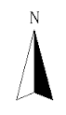
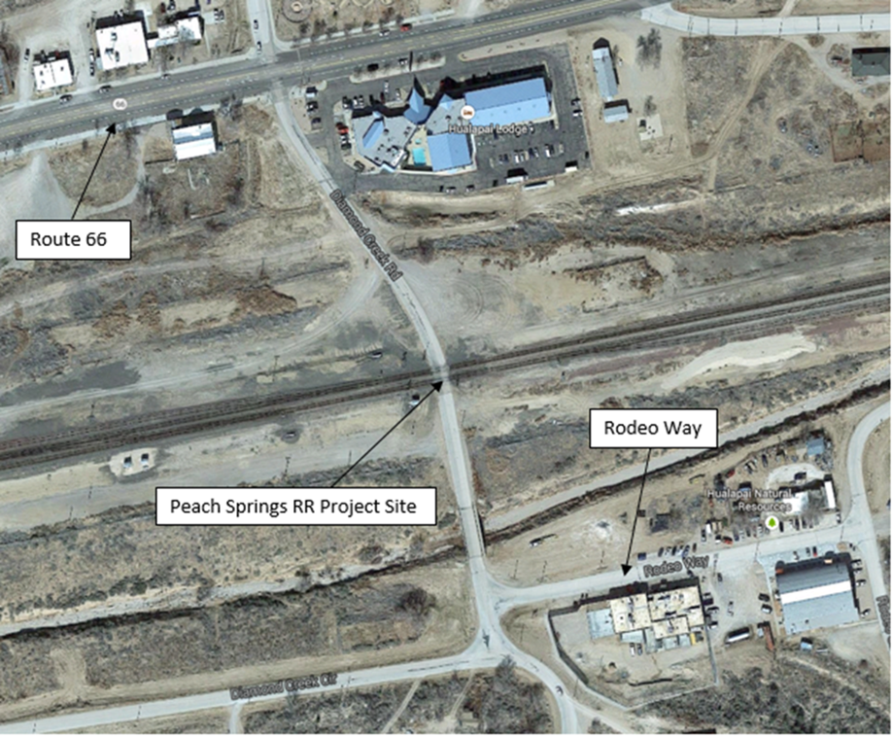
6.1 Figure 6.2: Peach Springs Aerial Map of site [1].

Figure 6.2: Existing Road and Proposed Road Alignment AutoCAD Surface.

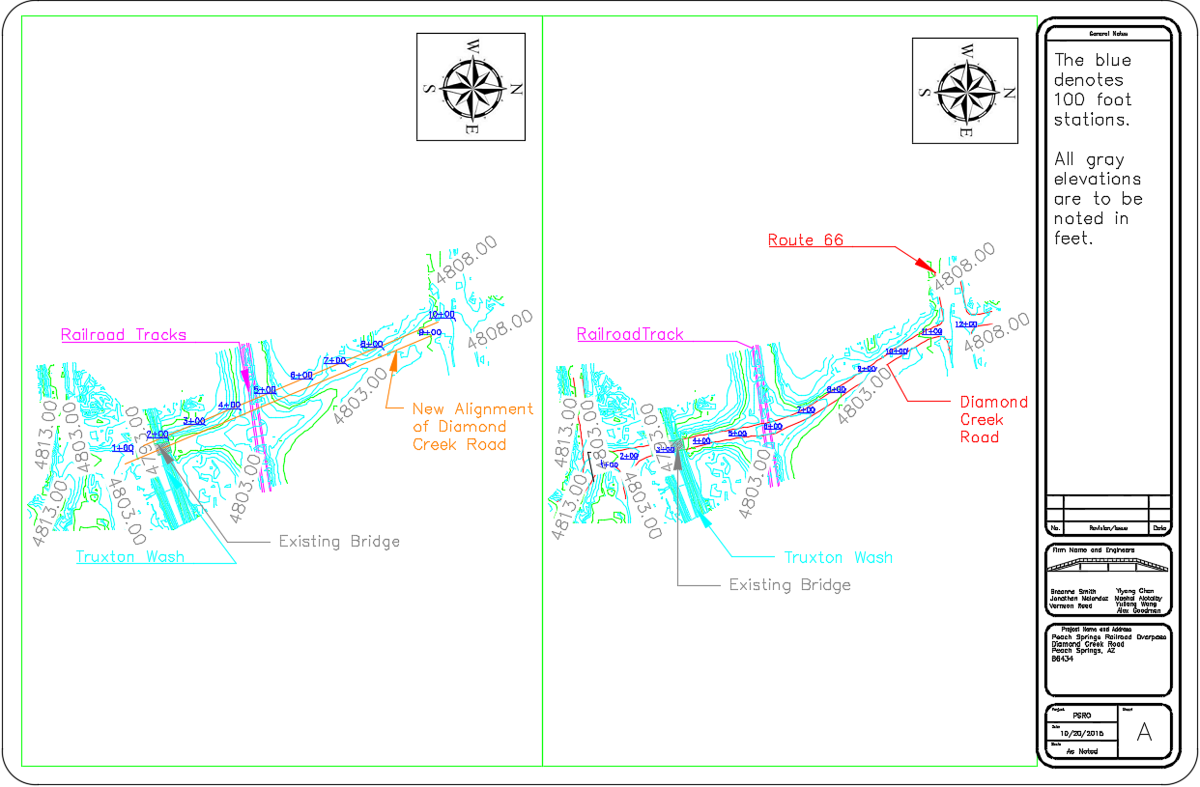

Figure 6.3: Entire Existing Available Road AutoCAD surface.

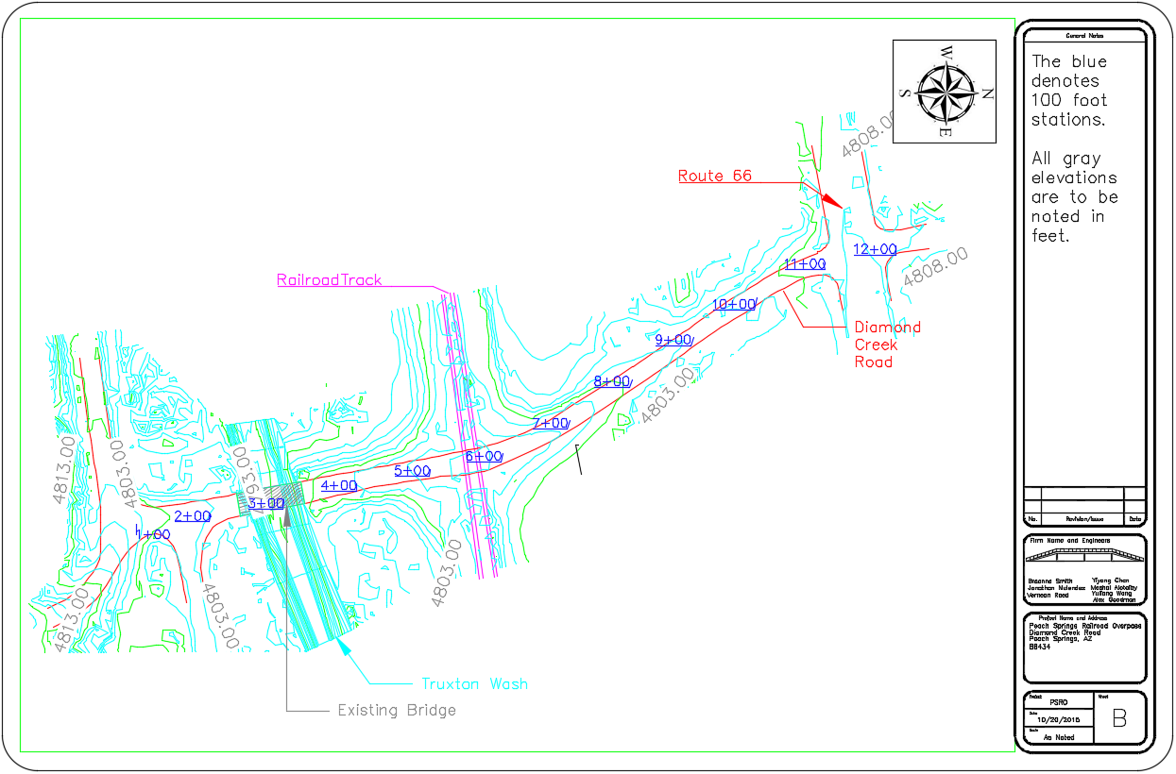

Figure 6.4: Proposed Road Alignment AutoCAD Surface.

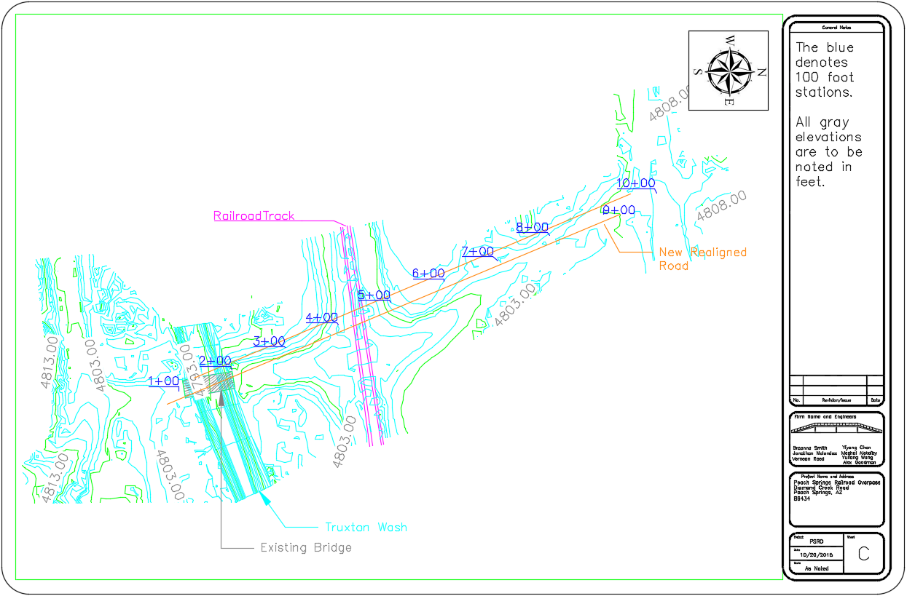

Figure 6.5: Truxton Wash and Railroad Section Cut from AutoCAD Surface

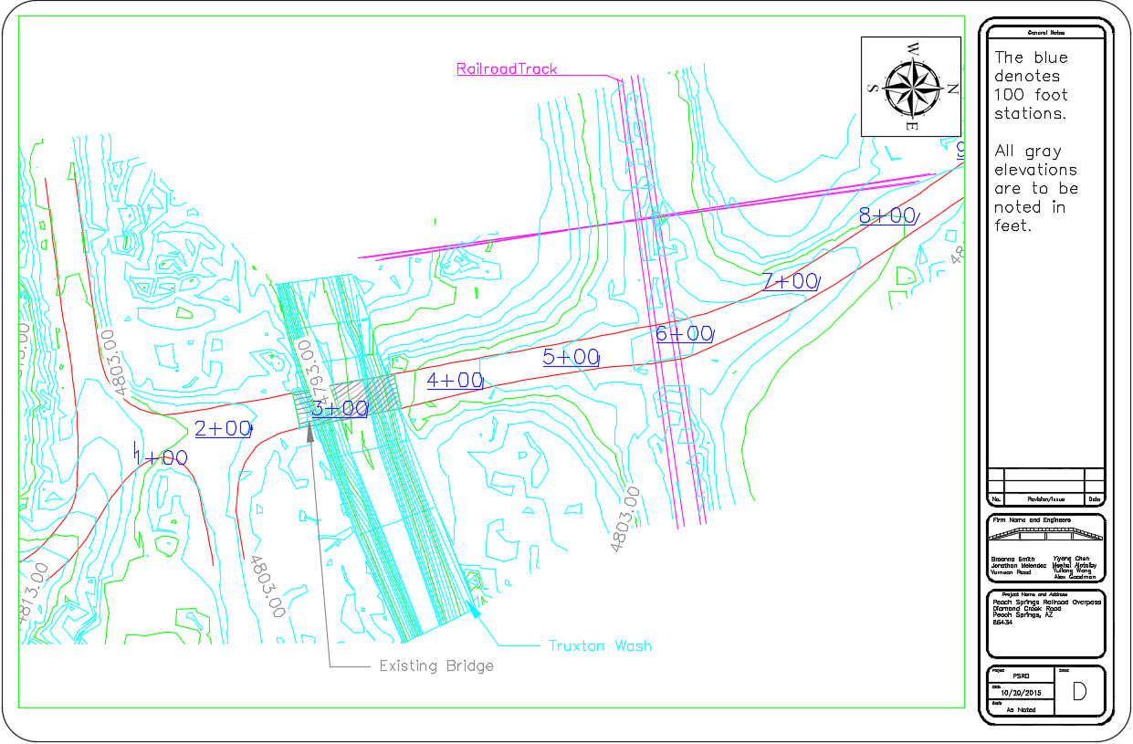

Figure 6.6: Bridge Design and Geometry from AutoCAD.

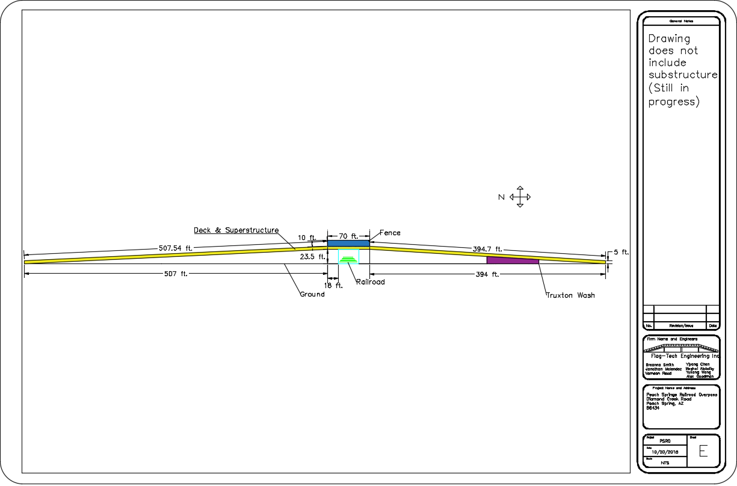

  - FHWA Codes:
The RRR design standards shall reflect the consideration of the traffic, safety, economic, physical, community, and environmental needs of the projects [4].
- Roadway and appurtenances.
(1) A Policy on Geometric Design of High- ways and Streets, AASHTO 2001. [See § 625.4(d) (1)]
(2) A Policy on Design Standards Interstate System, AASHTO, January 2005. [See § 625.4(d) (1)]
(3) The geometric design standards for resurfacing, restoration, and rehabilitation (RRR) projects on NHS high- ways other than freeways shall be the procedures and the design or design criteria established for individual projects, groups of projects, or all non- freeway RRR projects in a State, and as approved by the FHWA. The other geometric design standards in this section do not apply to RRR projects on NHS highways other than freeways, except as adopted on an individual State basis. The RRR design standards shall reflect the consideration of the traffic, safety, economic, physical, community, and environmental needs of the projects.
(4) Erosion and Sediment Control on Highway Construction Projects, refer to 23 CFR part 650, subpart B.
(5) Location and Hydraulic Design of Encroachments on Flood Plains, refer to 23 CFR part 650, subpart A.
(6) Procedures for Abatement of Highway Traffic Noise and Construction Noise, refer to 23 CFR part 772.
(7) Accommodation of Utilities, refer to 23 CFR part 645, subpart B.
(8) Pavement Design, refer to 23 CFR part 626.
- Bridges and structures.
(1) Standard Specifications for Highway Bridges, Fifteenth Edition, AASHTO 1992. [See § 625.4(d) (1)]
(2) Interim Specifications—Bridges, AASHTO 1993. [See § 625.4(d) (1)]
(3) Interim Specifications—Bridges, AASHTO 1994. [See § 625.4(d) (1)]
(4) Interim Specifications—Bridges, AASHTO 1995. [See § 625.4(d) (1)]
(5) AASHTO LRFD Bridge Design Specifications, First Edition, AASHTO 1994 (U.S. Units). [See § 625.4(d) (1)]
(6) AASHTO LRFD Bridge Design Specifications, First Edition, AASHTO 1994 (SI Units). [See § 625.4(d) (1)]
(7) Standard Specifications for Movable Highway Bridges, AASHTO 1988. [See § 625.4(d) (1)]
(8) Bridge Welding Code, ANSI/ AASHTO/AWS D1.5–95, AASHTO. [See § 625.4(d) (1) and (2)]
(9) Structural Welding Code—Rein- forcing Steel, ANSI/AWS D1.4–92, 1992. [See § 625.4(d) (2)]
(10) Standard Specifications for Structural Supports for Highway Signs, Luminaires and Traffic Signals, AASHTO 1994. [See § 625.4(d) (1)]
(11) Navigational Clearances for Bridges, refer to 23 CFR part 650, sub- part H.
- Materials.
(1) General Materials Requirements, refer to 23 CFR part 635, subpart D.
(2) Standard Specifications for Transportation Materials and Methods of Sampling and Testing, parts I and II, AASHTO 1995. [See § 625.4(d) (1)]
(3) Sampling and Testing of Materials and Construction, refer to 23 CFR part 637, subpart B.
  - ADOT Codes:

- Railways shall provide a minimum clearance of 23’-6” above top of rail. Clearance greater than 23’-6” may be approved when justified on the basis of electrification. - Arizona Department of Transportation [Bridge Practice Guidelines] “Section 2 – General Design & Location Features”
- Use the 100 year flood in order to assess flood hazards and meeting floodplain management. - Arizona Department of Transportation [Bridge Practice Guidelines] “Section 2 – General Design & Location Features”
- Where applicable, use debris racks to stop debris before it reaches the bridge. - Arizona Department of Transportation [Bridge Practice Guidelines] “Section 2 – General Design & Location Features”
- The dead load shall consist of the weight of entire structure, including the roadways, curbs, sidewalks, and railing. – Arizona Department of Transportation [Bridge Practice Guidelines] “Section 3 – Loads and Load Factors”
- Where deck forms are not required to be removed, an allowance of 5-10 lb/ft^2 for form dead load shall be included. - Arizona Department of Transportation [Bridge Practice Guidelines] “Section 3 – Loads and Load Factors”
- All new structures shall be designed to carry an additional dead load of 25 pounds per square foot from curb to curb of roadway to allow for a future wearing surface. - Arizona Department of Transportation [Bridge Practice Guidelines] “Section 3 – Loads and Load Factors”
- Design calculations of stream forces on piers over natural water courses shall assume a 2 foot increase in pier width per side due to blockage by debris with a shape factor k = 1.40 for the first 12 feet of depth of flow. (if flows with depth greater than 12 feet, only top 12 feet be assumed blocked by debris) - Arizona Department of Transportation [Bridge Practice Guidelines] “Section 3 – Loads and Load Factors”
- When the clear distance between columns or shafts is 16 feet or greater, each column or shaft shall be treated as an independent unit for stream forces and debris. When the clear distance is less than 16 feet the greater of the two following criteria shall be used:
- Each column or shaft acting as an independent unit or 2) all columns or shafts acting as one totally clogged unit. - Arizona Department of Transportation [Bridge Practice Guidelines] “Section 3 – Loads and Load Factors”
- A minimum angle of attack of 15 degrees shall be assumed. - Arizona Department of Transportation [Bridge Practice Guidelines] “Section 3 – Loads and Load Factors”
- Bridge foundation units outside the highwater prism need not be designed for scour or stream forces. Spread footing bearing elevations shall be minimum 5 ft. below the channel thalweg elevation. Tip of drilled shaft elevations shall be minimum 20 ft. below the channel thalweg elevation unless in rock sockets. - Arizona Department of Transportation [Bridge Practice Guidelines] “Section 3 – Loads and Load Factors”
- The vertical restraints shall be designed for a minimum force equal to 10 percent of the contributing dead load unless the Standard Specifications, Division I-A Seismic Design require a higher value. - Arizona Department of Transportation [Bridge Practice Guidelines] “Section 3 – Loads and Load Factors”
- Composite dead loads (such as curbs, barriers and wearing surfaces) are distributed equally to all stringers except for extraordinary conditions of deck width or ratio of overhang to beam spacing. - Arizona Department of Transportation [Bridge Practice Guidelines] “Section 3 – Loads and Load Factors”
- In calculating the number of lanes of live load on the superstructure, the entire cross section of the superstructure shall be considered as one unit with the number of lanes of live load equal to the out-to-out width of the deck divided by 14. - Arizona Department of Transportation [Bridge Practice Guidelines] “Section 3 – Loads and Load Factors”
- Rolled beams and plate girders shall be provided with cross-frames or diaphragms at each support and with intermediate cross-frames or diaphragms placed in all bays, at intervals not to exceed 25-feet. - Arizona Department of Transportation [Bridge Practice Guidelines] “Section 6 – Steel Structures”
- Welded cover plates shall be a minimum 1/2-inch narrower than the flange to which they are attached in order to accommodate a 1/4-inch fillet weld. - Arizona Department of Transportation [Bridge Practice Guidelines] “Section 6 – Steel Structures”
- Minimum concrete strength of bridge decks shall be, f’c = 4.5 ksi at 28 days. - Arizona Department of Transportation [Bridge Practice Guidelines] “Section 9 – Decks and Deck Systems”
- To provide protection against corrosion the minimum clear cover for reinforcing steel in new deck slabs shall be 2½ inch for top reinforcement and 1 inch for the bottom reinforcement. - Arizona Department of Transportation [Bridge Practice Guidelines] “Section 9 – Decks and Deck Systems”
- Only #5 or #6 bar sizes shall be used as primary reinforcement in the transverse direction and shall be spaced at 1/2-inch increments. Minimum reinforcing spacing shall be 5 inches. Normally maximum transverse reinforcement spacing should not exceed 9 inches. - Arizona Department of Transportation [Bridge Practice Guidelines] “Section 9 – Decks and Deck Systems”
- Concrete barriers on continuous superstructures should have a 1/2 inch open joint filled with bituminous joint filler located over piers. The joint should extend to within 8 inches of the deck surface with reinforcing below this level made continuous. - Arizona Department of Transportation [Bridge Practice Guidelines] “Section 9 – Decks and Deck Systems”
- The depth of footing shall be determined in consideration of the character of the foundation materials and the possibility of undermining. Footings at stream crossings shall be founded at a depth of at least 2.0 ft. below the maximum anticipated depth of scour as determined by the ADOT Bridge Hydraulics section and ADOT Geotechnical Section. - Arizona Department of Transportation [Bridge Practice Guidelines] “Section 10 – Foundations”
- The bottom of spread footings shall be set at least to the depth recommended in the bridge foundation report. The minimum top cover over the top of the footings shall be 1’-6. For footings located at elevations over 5,000 feet, the minimum depth of embedment to the bottom of footings shall be 6’-0 to prevent frost heave. - Arizona Department of Transportation [Bridge Practice Guidelines] “Section 10 – Foundations”
- Pipe Pile for 14 and 16 inch diameter steel pipes with 1/2 or 5/8 inch wall thickness are generally recommended for the shell. - Arizona Department of Transportation [Bridge Practice Guidelines] “Section 10 – Foundations”
- The calculated displacements used in determining the required displacement (i.e. the difference between the widest and the narrowest opening of a joint) shall be the sum of 1.2 times the movements caused by temperature changes and 1.0 times the shortening movement caused by creep and shrinkage. – Arizona Department of Transportation [Bridge Practice Guidelines] “Section 14 – Joints and Bearings”
- The effective displacement range may be up to 4 inches - Arizona Department of Transportation [Bridge Practice Guidelines] “Section 14 – Joints and Bearings”
- A minimum opening of 1.75 inches is preferred for easy installation but the seal can be installed in openings as small as 1.5 inches. The opening at the mean temperature should be set to 1.75 inches whenever possible. - Arizona Department of Transportation [Bridge Practice Guidelines] “Section 14 – Joints and Bearings”
- Pads shall have a minimum thickness of one inch and be designed in 1/2-inch increments. The use of elastomeric bearing pads should generally be limited to a thickness not greater than 5 inches. If the design pad thickness is 4½ inches or greater, a sliding plate bearing system should be investigated. - Arizona Department of Transportation [Bridge Practice Guidelines] “Section 14 – Joints and Bearings”
- Distribution of wheel loads for typical restressed concrete bridges with maximum girder spacing’s less than 10 feet, shall be as contained in AASHTO Article 3.23 using the column in Table 3.23.1 for One Traffic Lane. - Arizona Department of Transportation [Bridge Practice Guidelines] “Section 16 – Bridge Construction”
- The top ½” of the deck shall be considered as a wearing surface. The weight of the ½” wearing surface shall be included in the dead load but the ½” shall not be included in the depth of the structural section for all strength calculations including the deck, superstructure and the pier cap, where appropriate. - Arizona Department of Transportation [Bridge Practice Guidelines] “Section 3 – Loads and Load Factors”
- The lane loading or standard truck shall be assumed to occupy a width of 10 feet. These loads shall be placed in 12-foot wide design traffic lanes, spaced across the entire bridge roadway width measuring between curbs. - Arizona Department of Transportation [Bridge Practice Guidelines] “Section 3 – Loads and Load Factors”
- Fractional parts of design lanes shall not be used, but roadway width from 20 to 24 feet shall have two design lanes each equal to one-half the roadway width. - Arizona Department of Transportation [Bridge Practice Guidelines] “Section 3 – Loads and Load Factors”
- Provision shall be made for the effect of a longitudinal force of 5 percent of the live load in all lanes carrying traffic headed in the same direction without impact. - Arizona Department of Transportation [Bridge Practice Guidelines] “Section 3 – Loads and Load Factors”
- Centrifugal forces are included in all groups which contain vehicular live load. They act 6 feet above the roadway surface and are significant when curve radii are small or columns are long. - Arizona Department of Transportation [Bridge Practice Guidelines] “Section 3 – Loads and Load Factors”
- Cables restrainers used to restrain a bridge under seismic loads shall conform to 3/4-inch diameter preformed, 6 x 19, wire strand core or independent wire rope core (IWRC). - Arizona Department of Transportation [Bridge Practice Guidelines] “Section 6 – Steel Structures”
- A 3/4" V-drip groove shall be located on the underside of the deck overhang for all bridges - Arizona Department of Transportation [Bridge Practice Guidelines] “Section 9 – Decks and Deck Systems”
- The thickness of new deck slabs shall be designed in 1/2" increments with the minimum thickness as follows:

Where:
S = the effective span length specified in AASHTO LRFD Article 9.7.2.3
t = Minimum thickness of deck slab - Arizona Department of Transportation [Bridge Practice Guidelines] “Section 9 – Decks and Deck Systems”
- A minimum gap of 2 inches should be maintained between the railings and the sound walls. - Arizona Department of Transportation [Bridge Practice Guidelines] “Section 13 – Railings”
- Rustication on the exterior of bridge barriers and parapets shall be limited to a thickness of 1 ½ in. - Arizona Department of Transportation [Bridge Practice Guidelines] “Section 13 – Railings”
- Rustication may extend the full height of the barrier and parapet, excluding the 44-inch (nominal) F-shape bridge concrete barrier. The rustication height for 44-inch (nominal) F-shape barriers shall be limited to the bottom 32 inches, measured from the top of deck. - Arizona Department of Transportation [Bridge Practice Guidelines] “Section 13 – Railings”
- Snowplow protection for deck joint armor and joint seals may consist of:
Concrete buffer strips 12 to 18 inches wide with joint armor recessed 1/4 to 3/8 inches below the surface of such strips. - Arizona Department of Transportation [Bridge Practice Guidelines] “Section 14 – Joints and Bearings”
- Joint-edge armor embedded in concrete should have 1/2-inch diameter vertical vent holes spaced no more than 9 inch centers along the length of the armor. - Arizona Department of Transportation [Bridge Practice Guidelines] “Section 14 – Joints and Bearings”
- Joint designs shall include details for transverse field splices for staged construction and for joints longer than 60 feet. - Arizona Department of Transportation [Bridge Practice Guidelines] “Section 14 – Joints and Bearings”
- The method of seal termination in barriers, sidewalks and raised medians. In general the seal should be turned up a minimum of 6 inches or 2 inches above the high water depth at the curb to keep the roadway water in the roadway drainage collection system. To better seal the joint, and to minimize construction errors, the seal should be turned up at both the low and high sides. - Arizona Department of Transportation [Bridge Practice Guidelines] “Section 14 – Joints and Bearings”
- For bridges subjected to de-icing salts and for bridges located above 4,000 feet, the armor should be galvanized. The need for galvanizing shall be specified on the plans and in the special provisions. - Arizona Department of Transportation [Bridge Practice Guidelines] “Section 14 – Joints and Bearings”
- The compression seal element should have a shape factor of 1:1 (width to height) to minimize sidewall pressure. - Arizona Department of Transportation [Bridge Practice Guidelines] “Section 14 – Joints and Bearings”
- The effective displacement range is up to 2.5 inches. - Arizona Department of Transportation [Bridge Practice Guidelines] “Section 14 – Joints and Bearings”
- The maximum allowed skew for use of a compression seal is 45 degrees with 30 degrees being the preferred limit. - Arizona Department of Transportation [Bridge Practice Guidelines] “Section 14 – Joints and Bearings”
- Compression seals shall be supplied without splicing. Where the length of the deck joint is less than 60 feet, the deck joint shall be supplied in one piece and the seal may be factory installed. - Arizona Department of Transportation [Bridge Practice Guidelines] “Section 14 – Joints and Bearings”
- The width and length dimensions shall be detailed in increment of one inch. When used with prestressed I-girders, pads shall be sized a minimum width of 2 inches less than the nominal width of the girder base to accommodate the 3/4 inch side chamfer and shall be set back 2 inches from the end of the girder to avoid spalling of concrete from the girder ends. - Arizona Department of Transportation [Bridge Practice Guidelines] “Section 14 – Joints and Bearings”
- The minimum vertical clearance for falsework over freeways shall be 16 feet 0 inches. - Arizona Department of Transportation [Bridge Practice Guidelines] “Section 16 – Bridge Construction”
- A soil bearing a pressure of 3,000psf will normally be considered acceptable for analysis of falsework mudsills when no soils testing data is available and the soil will be in a dry condition. - Arizona Department of Transportation [Bridge Practice Guidelines] “Section 16 – Bridge Construction”
- DL based on 160pcf concrete. Structures with greater than 3100lb/ft. Dead Load per girder line will require special considerations for required falsework depths. - Arizona Department of Transportation [Bridge Practice Guidelines] “Section 16 – Bridge Construction”
- Strand hold-downs may vary horizontally plus or minus 10 inches from the points shown on the contract drawings. - Arizona Department of Transportation [Bridge Practice Guidelines] “Section 16 – Bridge Construction”
- The duct LOL (Lay out Line) dimensions should be accurately shown on the working drawing to within 1/8 inch of the theoretical dimension. - Arizona Department of Transportation [Bridge Practice Guidelines] “Section 16 – Bridge Construction”

